SUMMARY FOR ANNUAL REPORT

Project title: Modeling and Measurement of Gas Transport in Nuclear Fuels

Project number: 21A1050-028FP

Initiative:   
Nuclear Reactor Sustainment and Expanded Deployment: Transformational Approaches to Accelerate Nuclear RD&D

Core Capabilities:

* Computational Science
* Nuclear Engineering

Total approved amount: $885,000 over 3 years

Principal investigator: Kyle Gamble

Co-investigators:

* Kaustubh Bawane, INL
* Fabiola Cappia, INL
* Chase Christen, INL
* Seongtae Kwon, INL

Collaborators:

* Politecnico di Milano

Impact Statement:

X-ray computed tomography and digital image analysis expedite development of microstructurally informed computational models in support of accelerated fuel qualification.

Project Description:

Accelerated fuel qualification relies on the development of approaches that combine physics-based modeling and experiments. One of the less understood phenomena associated with gas behavior in fuel rods is axial gas transport, which is important in spent fuel storage of light water reactor (LWR) fuel rods, loss-of-coolant accidents (LOCAs), and helium bonded fast reactor fuel rods. Prior to this project, the permeability of gas flow was computed after experiment completion and existing modeling approaches assume instantaneous equilibration of the pressure in the fuel rod. Neither existing experimental measurement or models account for the fragmented state of the fuel or the size of the fuel-to-clad gap. To overcome these limitations a methodology was developed to use advanced modeling and simulation to inform experiment design and use the experimental measurements and characterization techniques to develop more physics-based models to describe axial gas transport. First, the scalability of the axial gas transport phenomena was studied using the Multiphysics Object-Oriented Simulation Environment (MOOSE) framework and BISON nuclear fuel performance code. It was found that small 5-to-6-inch specimens would still allow for the measurement of pressure decay. The small samples enabled the use of X-ray computed tomography (CT) to generated hundreds of two-dimensional images that use digital image analysis to obtain important characteristics of the fragmented status of the surrogate fuel (alumina) such as crack tortuosity, specific surface, and porosity distribution. Full three-dimensional (3D) reconstruction of the experimental specimens was also possible. Surrogate materials were selected as gas transport only depends upon the available pathways for gas flow. Temperature and viscosity effects are considered in the modeling activities. Two approaches to specimen fabrication were considered, thermal quenching and mechanical crushing. It was observed that thermal quenching provided more representative fracture patterns and mechanical crushing resulted in much larger pathways for gas flow. An experimental apparatus was commissioned at the Research Collaboration Building (RCB) at the Materials Fuels Complex (MFC) to test the samples. The experiments conducted as part of the project were characterized and digital image correlation was performed to develop a new model for the permeability through fragmented fuel pellets as a function of smeared porosity. The project also determined that pressure equilibration is not instantaneous and gas flow is turbulent for shorter decay times.

Talent pipeline:

* Chiara Genoni, student at Politecnico di Milano
* Tommaso Bergomi, student at Politecnico di Milano

External peer reviewed publications:

* C. Genoni, K. A. Gamble, F. Cappia, C. E. Christen, S. Kwon, K. K. Bawane, “Modeling and Measurement of Axial Gas Transport in Nuclear Fuels,” in Transactions of the American Nuclear Society Annual Conference, Indianapolis, IN, June 2023. INL/CON-23-71205.

Figure and caption:

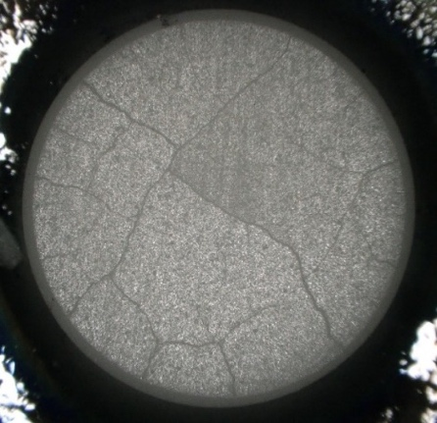

Figure 1: (a) top view of thermal quenched pellet, (b) image analysis of a single CT slice, (c) 3D reconstruction of pellet from hundreds of two-dimensional images, (d) best-fit curves including and excluding the Forchheimer coefficient in the model for test tube 1 at an initial pressure of 4.3 MPa. The Forchheimer coefficient accounts for turbulent gas flow.

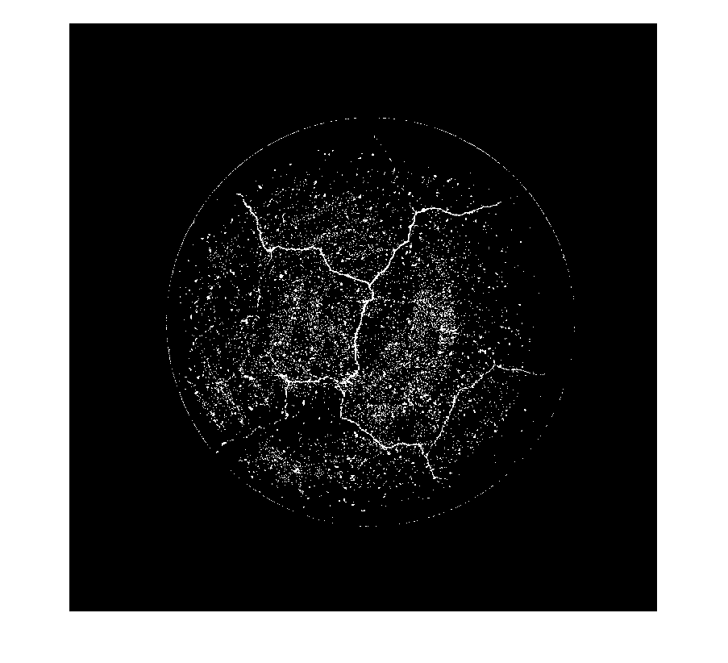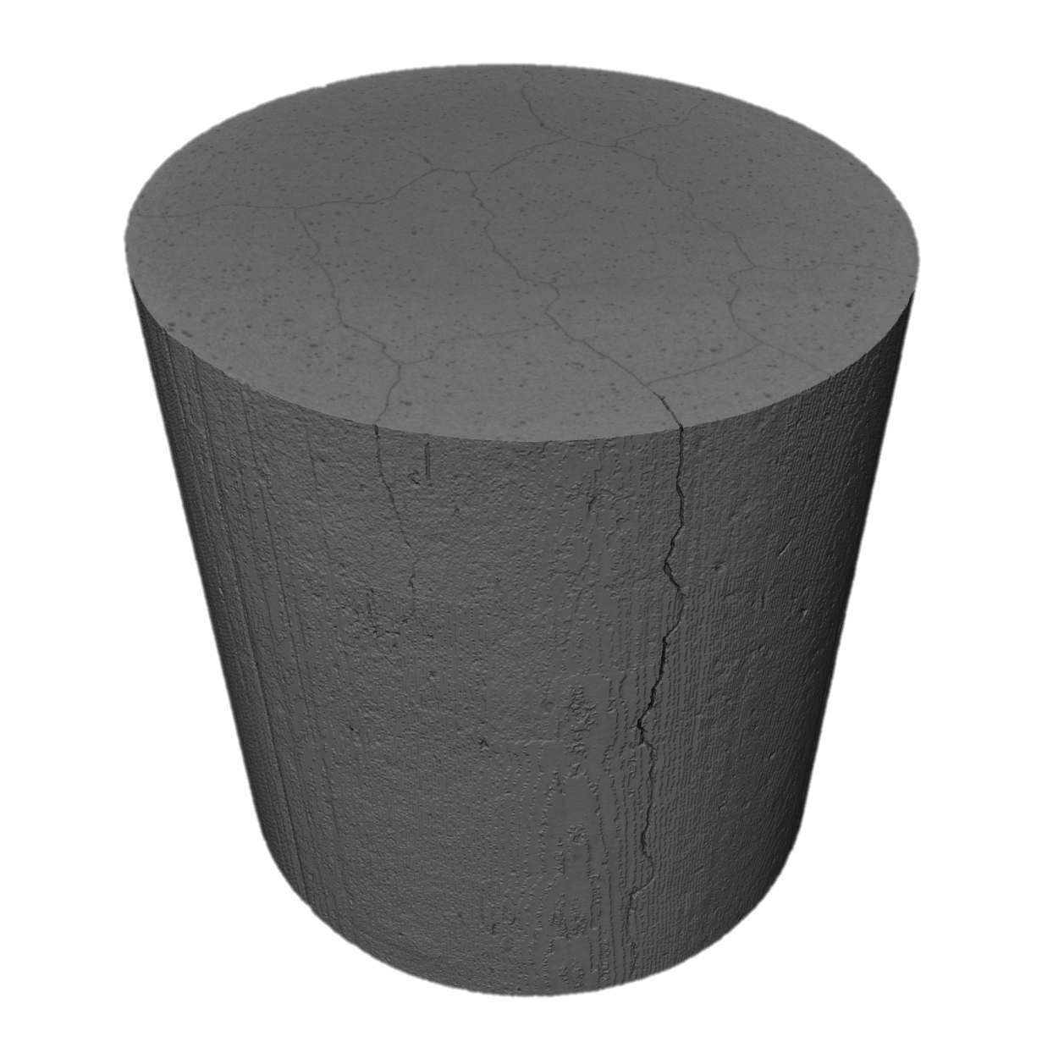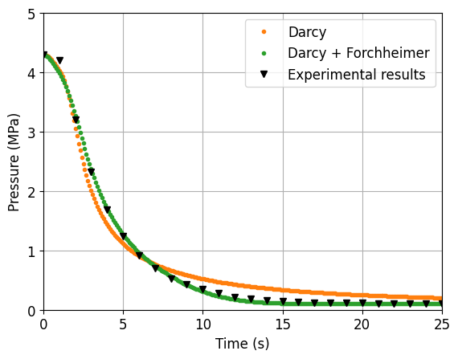

**(a)**

**(b)**

**(c)**

**(d)**

# SCIENTIFIC AND TECHNICAL ACCOMPLISHMENTS

A methodology was developed that demonstrated the feasibility of using modeling and simulation coupled with advanced characterization techniques to create a more physics-based model for the phenomenon of axial gas transport in nuclear fuel rods. Physics-based models are essential for accelerated fuel qualification. The project contained accomplishments in five key areas: determination of scalability, surrogate sample fabrication, experimental apparatus design and qualification, digital image analysis, and computational fuel performance model development.

**Scalability:** The success of the entire project hinged on ensuring that the axial gas transport phenomenon was scalable, otherwise full characterization of the fragmentation features would not have been possible as full-length rods (4 m long) would not fit in the x-ray CT machine. To determine scalability, a small study was performed that assumed constant values for the initial gas pressure, viscosity of the gas, and permeability of the fuel. The length and diameter of simulated region was varied, and the pressure decay computed. The results of the scalability study are shown in Figure 2. This study indicated that pressure decay could be measured on short length specimens that could be fully imaged in x-ray CT.

**(a)**

**(b)**

Figure 2: Depressurization of V1 as a function of time for (a) varying specimen lengths and (b) varying specimen diameters.

**Surrogate sample fabrication:** Two different approaches to fabricate the fractured surrogate fuel were explored. The first was thermal quenching (shock) where alumina pellets were raised temperatures ranging from 700 to 1100oC and then water quenched. Some specimens were repeatedly quenched to determine if there were additional cracking due to the subsequent quenches. It was found that the resultant fracture patterns were insensitive to the temperature at which quenching occurred or the number of cycles (see Figure 3). The second approach was mechanical crushing of pellets. Mechanical crushing of both fresh and previously thermally quenched samples were performed. It was found that diametric mechanical compression of fresh pellets resulted in complete breakup of the specimen whereas quenched specimens produced wider gap fractures while maintaining mechanical integrity with assistance of mylar wrapping. Mechanical compression and fabrication of the fuel pellet stacks for the experimental were wrapped in thermally shrinking mylar to ensure the specimen remained in position during both imaging and experimental testing.

900°C1 time

700°C 1 time

1100°C  
6 times

1100°C  
4 times

Figure 3: Thermally shocked alumina pellets by water quenching from various temperatures and with different numbers of times quenching was performed.

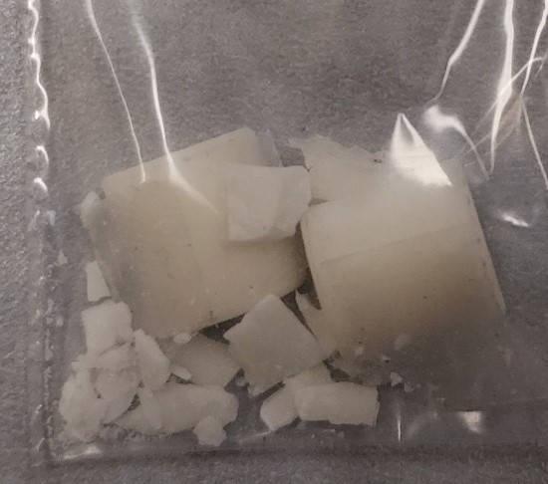

Figure 4: Mechanically crushed fresh pellet (left), single mechanical compression of quenched pellet (center), and double compression of quenched pellet (right).

**Experimental apparatus:** An experimental apparatus was designed and qualified to the requirements set out by the American Society of Mechanical Engineers (ASME) B31.3 Process Piping standard. In addition, required documentation is available in the Electronic Document Management System (EDMS):

* Engineering Calculation and Analysis Report (ECAR) ECAR-5842 “Axial Gas Communication (Laboratory Directed Research and Development) LDRD Experiment Piping Analysis”.
* Laboratory Instruction (LI) for the Research Collaboration Building (RCB) released, RCB-LI-0004 “MEASUREMENT OF GAS TRANSPORT IN NUCLEAR FUELS IN THE RESEARCH COLLABORATION BUILDING LABORATORY”

To date, several experiments have been completed providing valuable pressure decay data for computational model development. The details of the specimens are outlined in Table 1.

Table 1: List of experimental specimens. Crushed and quenched pellets indicate fracture induced by mechanical and thermal loading, respectively.

|  |  |  |  |
| --- | --- | --- | --- |
| **Specimen ID** | **Pellet Status** | **Number**  **of**  **Pellets** | **Gap Status** |
| Test tube 1 (TT1) | Crushed | 4 | Open |
| Test tube 2 (TT2) | Crushed | 8 | Open |
| Control tube 1 (CT1) | Fresh | 4 | Open |
| Control tube 2 (CT2) | Quenched | 4 | Open |
| Control tube 3 (CT3) | Fresh | 6 | Closed |
| Control tube 4 (CT4) | Quenched | 4 | Closed |
| Control tube 5 (CT5) | Fresh | 8 | Closed |
| Control tube 6 (CT6) | Fresh | 4 | Closed |
| Control tube 7 (CT7) | Fresh | 4 | Closed |

**Digital image analysis:** X-ray CT of alumina pellets was performed using a Zeiss Xradia Versa X-ray microscope (Carl Zeiss X-ray Microscopy INC., Dublin, CA, USA). X-ray CT data involved over ~2000 2-dimensional (2D) X-ray cross section images per specimen. These 2D X-ray images were analyzed for cracks and pores using MATLAB 2019b image processing tools. The steps used for the MATLAB analysis are shown in Figure 5. A k-means clustering approach for crack segmentation is being pursued to compare to the multi-threshold approach to provide additional data for improvements to the permeability model developed in this project.

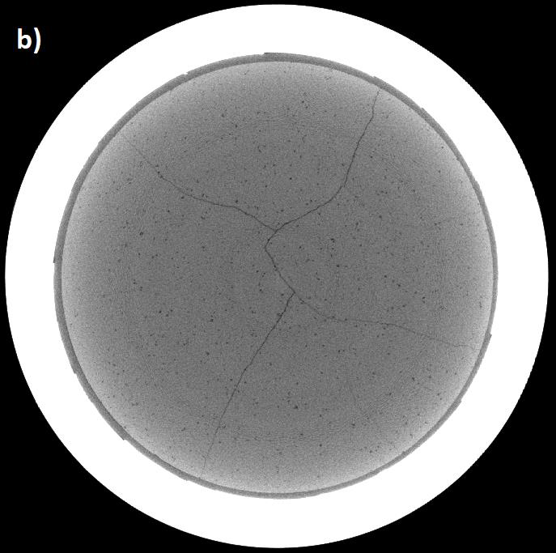

Figure 5: Crack and pore segmentation of X-ray images using MATLAB: (a) original X-ray image, (b) autocontrast and image negation (c) cropping pellet region, (d) crack segmentation using multi-threshold technique and binarization.

**Computational model development**: Two modeling approaches have been performed in parallel in support of this project. One is the implementation of an existing model that accounts for gas flow through the pellet-to-cladding gap as well as the fragmented pellets from the literature. This model provides a framework for axial gas transport modeling in a fuel performance code like BISON. The second approach uses computational fluid dynamics (CFD) capabilities in MOOSE to predict the pressure decay in specimens using the experimentally measured data and digital image analysis information. These simulations are used to develop a correlation for permeability of flow through the fragmented pellets. This correlation is designed to replace the one from the literature model for flow pathway through fragmented pellets. Figure 4 provides an example of using the CFD capabilities in MOOSE to compute the pressure decay at various initial pressure levels for control tube 4. An excellent match to the experimental data is obtained.

Figure 6: Best-fit curves for experiment CT4 at different pressure levels.

# BENEFITS TO DEPARTMENT OF ENERGY (DOE)

This project has set the engineering and modeling basis to perform axial gas transport studies in nuclear fuels at INL. The experimental apparatus is designed to be versatile, and this set-up can be easily adapted to different fuel designs to serve different programs within the DOE/National Nuclear Security Administration (NNSA). In the short term, outcomes of this project are relevant for the Used Fuel Program (see for instance TEV-4234) and the sustainability of the existing fleet through burnup extensions by industry. The modeling capabilities added to BISON will further INL’s expertise in advanced modeling and simulation of nuclear fuels. Development of a model for permeability of ceramic nuclear fuel utilizing x-ray CT imaged experimental specimens is a first-of-its kind.

# PROGRAM DEVELOPMENT ACCOMPLISHMENTS

The experimental work completed in this project provides a proof-of-concept capability that enables full characterization of specimens. The initial capability provides INL (and the United States) with experimental capabilities to look at axial gas transport in fuel rods (LWR and helium-bonded fast reactor) using surrogate materials, which is currently lacking in the country. The experimental capabilities could be used either by third-party customers (e.g., nuclear fuel vendors or the Nuclear Regulatory Commission) or by other research institutions as part of the Nuclear Science User Facilities (NSUF) to investigate the gas behavior in existing and next generation fuel concepts during accident-like and dry storage conditions. Moreover, the new modeling capabilities in BISON are available for use by all users including industry. The use of 3D x-ray tomography to obtain detailed pre-characterization of specimens for modeling purpose puts INL at the forefront of advanced modeling and simulation coupled with experimental capabilities. Industry partners can also utilize the Gateway for Accelerated Innovation in Nuclear (GAIN) program for access to the experimental capabilities.

A technology commercialization fund (TCF) project was awarded in FY20 but the statement of work was not finalized until FY23. This project titled “Targeting Analytic Tool Development Supporting Licensing of Higher Burnup/Higher Enrichment Nuclear Fuels for the U.S. Light Water Reactor Fleet” is providing support for continued modeling activities related to axial gas transport under CRADA No. 22TCF2 in collaboration with the Electric Power Research Institute.

# RESEARCH OUTPUTS

C. Genoni, K. A. Gamble, F. Cappia, C. E. Christen, S. Kwon, K. K. Bawane, “Modeling and Measurement of Axial Gas Transport in Nuclear Fuels,” in Transactions of the American Nuclear Society Annual Conference, Indianapolis, IN, June 2023. INL/CON-23-71205.

S. Kwon, K. A. Gamble, F. Cappia, C. E. Christen, K. K. Bawane, “Fabrication of Surrogate Oxide Spent Fuel with Various Cracking Patterns and the Design of an Axial Gas Transport Apparatus,” Journal of Nuclear Materials (planned submission October 2023).

C. Genoni, D. Pizzocri, K. A. Gamble, F. Cappia, T. Bergomi, “Investigation of the Impact of Non-Uniform Permeability on Axial Gas Transport within Light Water Reactor Fuel Rods during a Loss of Coolant Accident and Clad Failure,” Journal of Nuclear Materials (planned submission December 2023).

T. Bergomi, “Fuel Pellets Three-Dimensional Properties Reconstruction Exploiting Image Analysis: A Bridge Between Experiments and Modeling”, Master’s Thesis, Politecnico di Milano (spring 2024).